CONFERENCE MANAGEMENT

USE CASE DIAGRAM

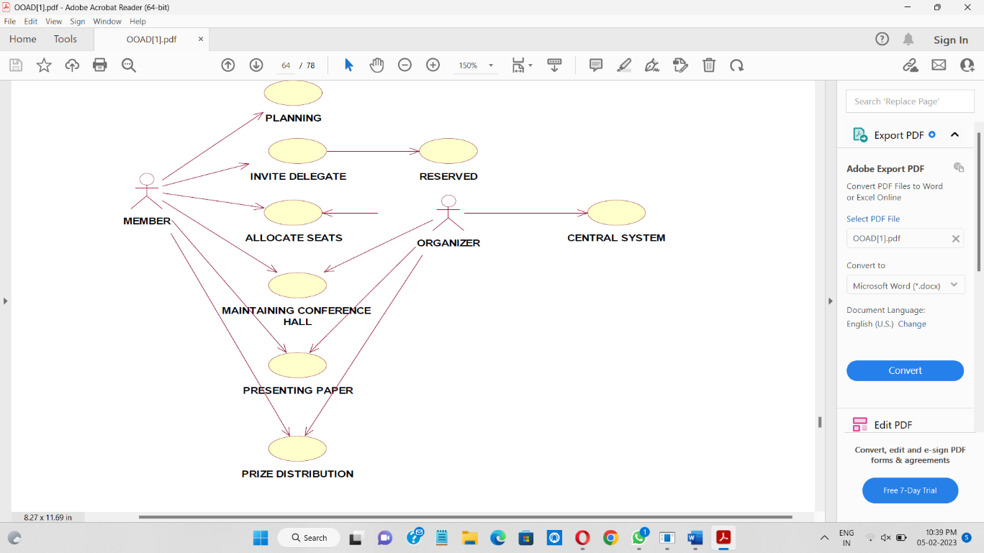

CLASS DIAGRAM

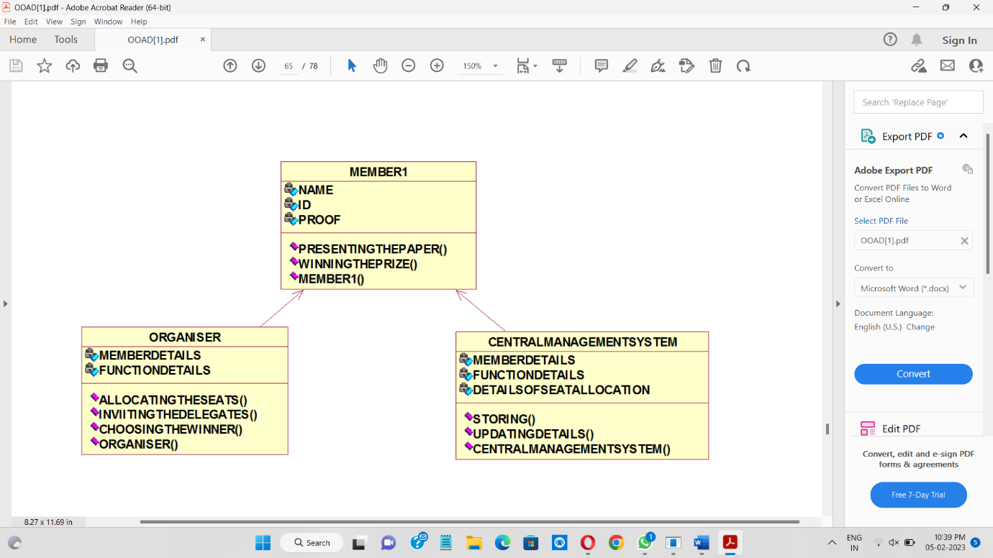

SEQUENCE DIAGRAM

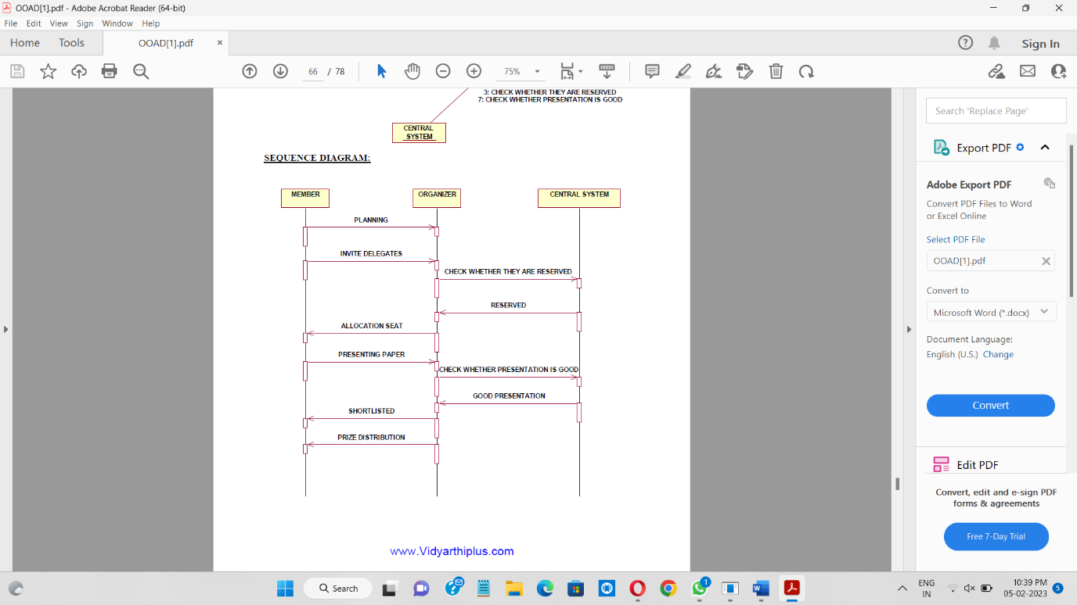

SEQUENCE DIAGRAM

